**Typography  
  
SANS SERIF FONT FOR THE HEADING**

For the headings and body text, I advise choosing a font combination like Open Sans and Merriweather.  
  
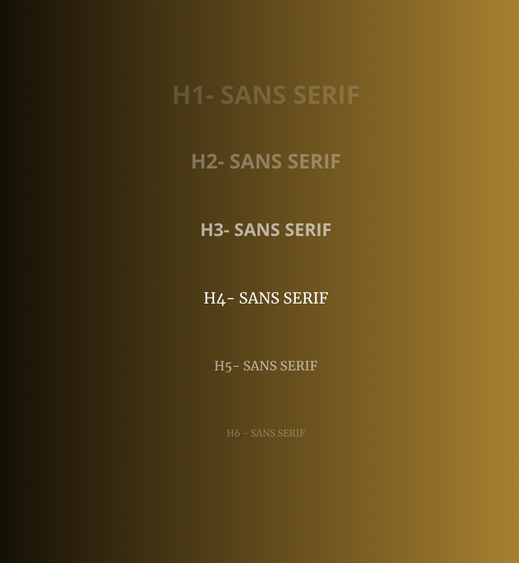

**Theme Colors**

COLOUR PALETTES:

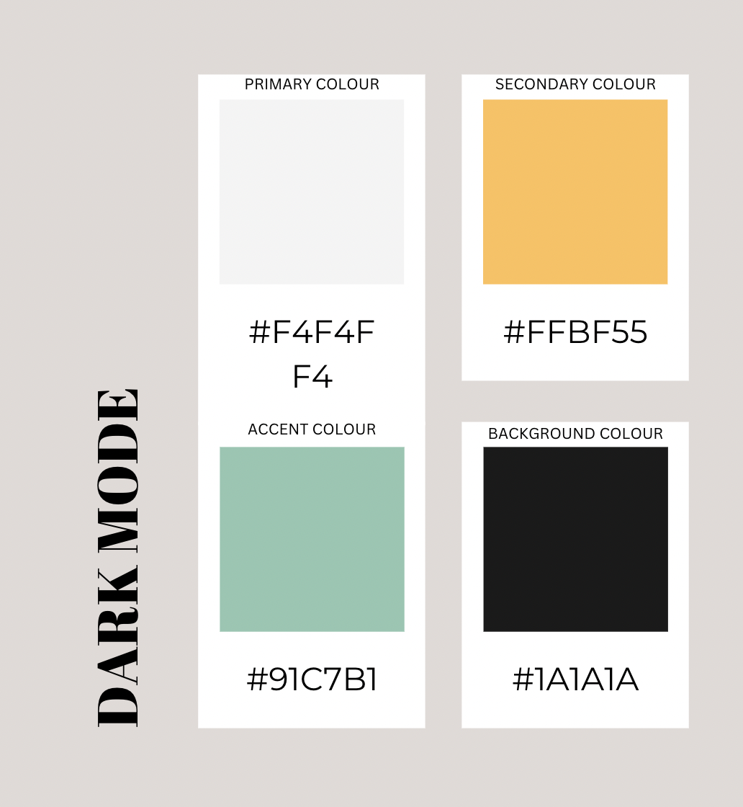

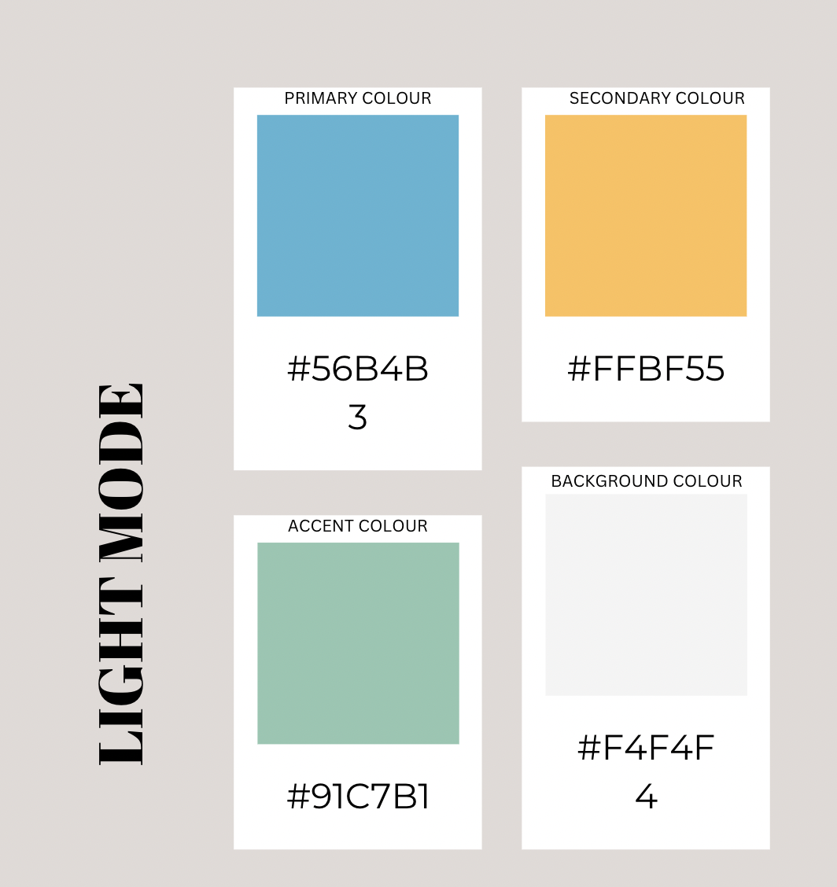

CHAMELEON WEBSITE LOGO(NORMAL AND DUAL TONE)

